|  |
| --- |
| NGS INFONET |

Employee Name: PRIYANK AMBATI Guide: ABHAY BAKSHI

Issue occurred of missing menu entry values in the senior centers which where newly created

1. Info from Priyank, Abhay, Binoy is the cause might be the user using the browser navigation instead of App navigation which caused the loss of saving data.
2. Pradeep advised to check the program timezone columns and run the search queries

Binoy shared the Prod Db credentials to check it

1. NFesh Prod DB Access:

The Host endpoint is : [nfesh-rds-postgres.copyt1i9jcc2.us-east-1.rds.amazonaws.com](http://nfesh-rds-postgres.copyt1i9jcc2.us-east-1.rds.amazonaws.com)

Username is reports and the password is reports

Please note that with this login, you would only be able to run select queries and won't be able to update or delete anything in the database. Yet, I would say, be extra careful **NOT** to try to execute any update or delete statements in the Production environment

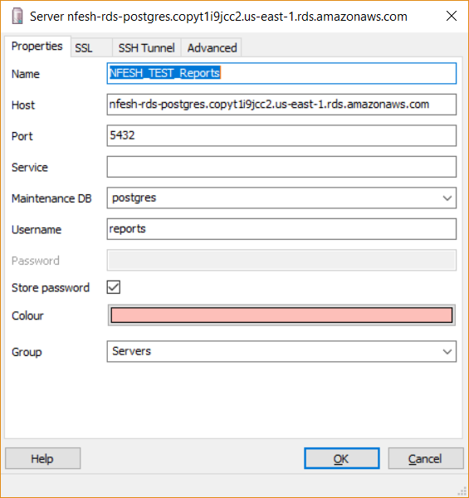

Db access for Dev DB

Host: nfeshdevdb.copyt1i9jcc2.us-east-1.rds.amazonaws.com:5432

Username:postgres, Password: apassword

Pem file for Prod/Dev Server: 

Dev Remote host: 34.193.165.33, Prod remote host: 52.71.162.79

username: ubuntu, port:22, use perm file as private key

Nfesh-Dev-site: .193.165.33:8080/WhatAWaste username: admin, Password: admin

1. Info from Pradeep the program time zones where showing as null and not updated automatically by the code. Which might cause the error.
2. Pradeep has told me to create a new program in DEV Environment and check the program time zone columns value
3. Priyank was able to create the new program as told by Pradeep and found the database value of program time zone column is “null”
4. Cause: Hence the exact issue is still unknown but we came to know that the code failed to update the timezone column which failed to save the menus created
5. Solution: for now, Pradeep informed that He has updated it manually the time zone columns and looking into the code and will update on it.
6. Pradeep made correction to program time zone columns and deployed new war file in dev and asked Priyank to test it.
7. Priyank tested and shard the result to pradeep